Template for the Preparation of the Manuscript for “HMnS2022”
John Smith¹, Peter Meier², Anne Miller²
¹Affiliation, Address, e-mail-address of corresponding author
²Affiliation, Address
Abstract
In order to facilitate writing your extended abstract for the “HMnS2022” we provide you with this MS Word document template. Using this template will keep your effort to prepare the paper low and will ensure a smooth editing of the conference proceedings.
Keywords
Manuscript, template, preparation, proceedings, HMnS (please define 3-5 keywords)

Dear author
- The extended abstract for the “HMnS2022” as an electronic document must include all figures and tables. Please integrate them into the text, not at the end of the paper. The maximum length of the extended abstract is 4 pages.
- If you do not use MS Word for preparing the document, use Rich Text Format (*.rtf). Do NOT send a document in Acrobat’s Portable File Format (*.pdf) because we possibly need to edit the document for the proceedings.
- Deadline for submission of the 4-page extended abstract is 28 February 2022 via www.hmns2022.org.
- In case of any questions with respect to the preparation of the paper, please, do not hesitate to contact us.
- We thank you very much for contributing to the “HMnS2022” and are looking forward to your presentation. The Organizing Team

Introduction
The template contains specific styles for all typical elements in your paper (e.g. for title, headings, text, captions, references, etc.). Using these styles ensures that all papers in the HMnS2022 proceedings will have the same layout.

Using the Styles of the Template
Formatting the paper is rather simple: All you have to do is to select the paragraph, which you want to format and overwrite. This makes formatting easy.
If you do not wish to use this template or if you need further details defining the styles you find them listed at the end of this template as they appear in the paper.

Examples

Enumerations
Example for an enumeration with bullets:
- Enumeration item with a bullet
- A second item
Example for an enumeration with numbers:
- Enumeration item with a number
- A second item

Figures and Tables
Example for a figure and its caption. Refer to each figure in the text as follows with its numeration (Figure 1):
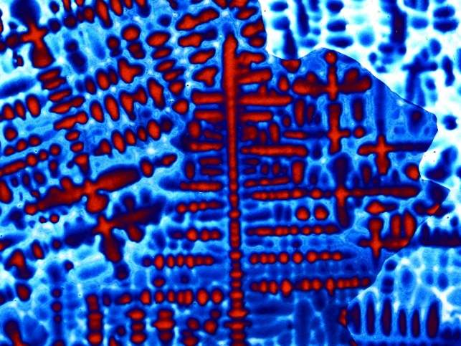
Figure 1: Figures are centred, captions are left aligned
Example for a table and its caption above (Table 1):
Table 1: Spacing and font size is different for text, figures and tables.
 | Font Size | Spacing Before | Spacing After
Text | 12 | 0 pt | 4 pt
Figure | defined by figure | 6 pt | 4 pt
Table | 11 | 2 pt | 2 pt
Caption | 11 | 4 pt | 4 pt
References are indicated by square brackets containing the family names of the authors and the year of the publishing, e.g. [Wesselmecking 2018], [Song 2014] [Bleck 2018]. The references are listed at the end of the document in alphabetical order.
Acknowledgement
This work has been partly funded by ... The authors wish to acknowledge the ... for their support. We also wish to acknowledge our gratitude and appreciation to all ... partners for their contribution during the development of various ideas and concepts presented in this paper.
References
Bleck, W.; Moeller, E.: Handbuch Stahl, Carl Hanser Verlag, München, 2018
Song, W.; Ingendahl, T.; Bleck, W.: Control of strain hardening behavior in high-Mn austenitic steels. Acta Metall. Sin. (Engl. Lett.), 27 (2014) 3, S.546-556
Wesselmecking, S.; Song, W.; Ma, Y.; Roesler, T.; Hofmann, H.; Bleck, W.: Strain aging behavior of an austenitic high-Mn steel. Steel Research International 2018, 1700515 doi.org/10.1002/srin.201700515
Paper size:  DIN A4 (210 × 297 mm)  4 pages maximum | Abstract Heading:  Size 10 pt  Spacing before 12 pt  Spacing after 4 pt  Bold, not italic, no capitals  Left alignment
Language:
English
Text (normal paragraphs) (Standard):  Size 12 pt  Spacing before 0 pt  Spacing after 4 pt  Justified  No indentation | Abstract Text:  Size 10 pt  Spacing before 0 pt  Spacing after 4 pt  Justified  100-150 words
Margins:  Top 25 mm, Bottom 15 mm  Left 28 mm, Right 28 mm  Text width 154 mm  Text height 257 mm | Keywords Heading:  Size 10 pt, Left alignment  Spacing before 12 pt  Spacing after 4 pt  Bold, not italic, no capitals
Page Layout:  No header  No footer  No page numbers | Keywords: 3-5 keywords  Size 10 pt, Left alignment  Spacing before 0 pt  Spacing after 4 pt
Font:  Arial for all text, including headings, captions, etc.  Single spacing | Heading Level 1:  Size 14 pt  Spacing before 12 pt, after 12 pt  Not bold, not italic, not capitals  Upper and lower case  Left alignment, Numbered
Title:  Size 24 pt  Spacing before 30 pt  Spacing after 4 pt  Not bold, not italic, no capitals  Upper and lower case  Centred | Heading Level 2:  Size 13 pt  Spacing before 6 pt, after 6 pt  Not bold, not italic, not capitals  Upper and lower case  Left alignment  Numbered
Author(s) Name(s):  Size 12 pt  Spacing before 18 pt  Spacing after 4 pt  Not bold, not italic, no capitals  Upper and lower case  Centred | Heading Level 3:  Should be avoided (!)  Size 12 pt  Spacing before 4 pt, after 4 pt  Not bold, not italic, not capitals  Upper and lower case  Left alignment  Numbered
Author(s) Address(es):  Size 11 pt  Spacing before 0 pt  Spacing after 4 pt  Italic, not bold  Centred  Superscripted numbers for link to author (i.e. ¹ ² ³)  Address, Email, no phone, no fax | Enumerations:  Size 12 pt  Spacing before 0 pt, after 4 pt  Indentation left 5 mm  Hanging indentation 5 mm  Three types may be used:  • bullets  1 numbers  No special types like ♠,→,◊,⊕, etc.
Figure:  Spacing before 6 pt  Spacing after 4 pt  Centred on page  Inserted where they appear in the text  Not larger than text area  Suitable for black and white printing  Followed by caption | Acknowledgement Heading:  Size 10 pt  Spacing before 12 pt  Spacing after 4 pt  Bold, not italic, no capitals  Left alignment  Not numbered
Figure Caption:  Size 11 pt  Spacing before 4 pt  Spacing after 4 pt  Left aligned below figure  Numbered as Figure 1: | Acknowledgement Text:  Size 10 pt  Spacing before 0 pt  Spacing after 4 pt  Justified
Table:  Size 11 pt  Spacing before 2 pt  Spacing after 2 pt  Centred on page  Not larger than text area  Caption above | Reference Heading:  Size 10 pt  Spacing before 12 pt  Spacing after 4 pt  Bold, not italic, no capitals  Left alignment  Not numbered
Table Caption:  Size 11 pt  Spacing before 4 pt  Spacing after 4 pt  Left aligned above table  Numbered as Table 1: | References:  Size 10 pt  Spacing before 0 pt  Spacing after 4 pt  Hanging indentation 7,5 mm  Left alignment  Not numbered, references in the text by [Author name, year]  Alphabetical listing  All references cited in the text

